CS 255 System Design Document

UML Diagrams

UML Use Case Diagram
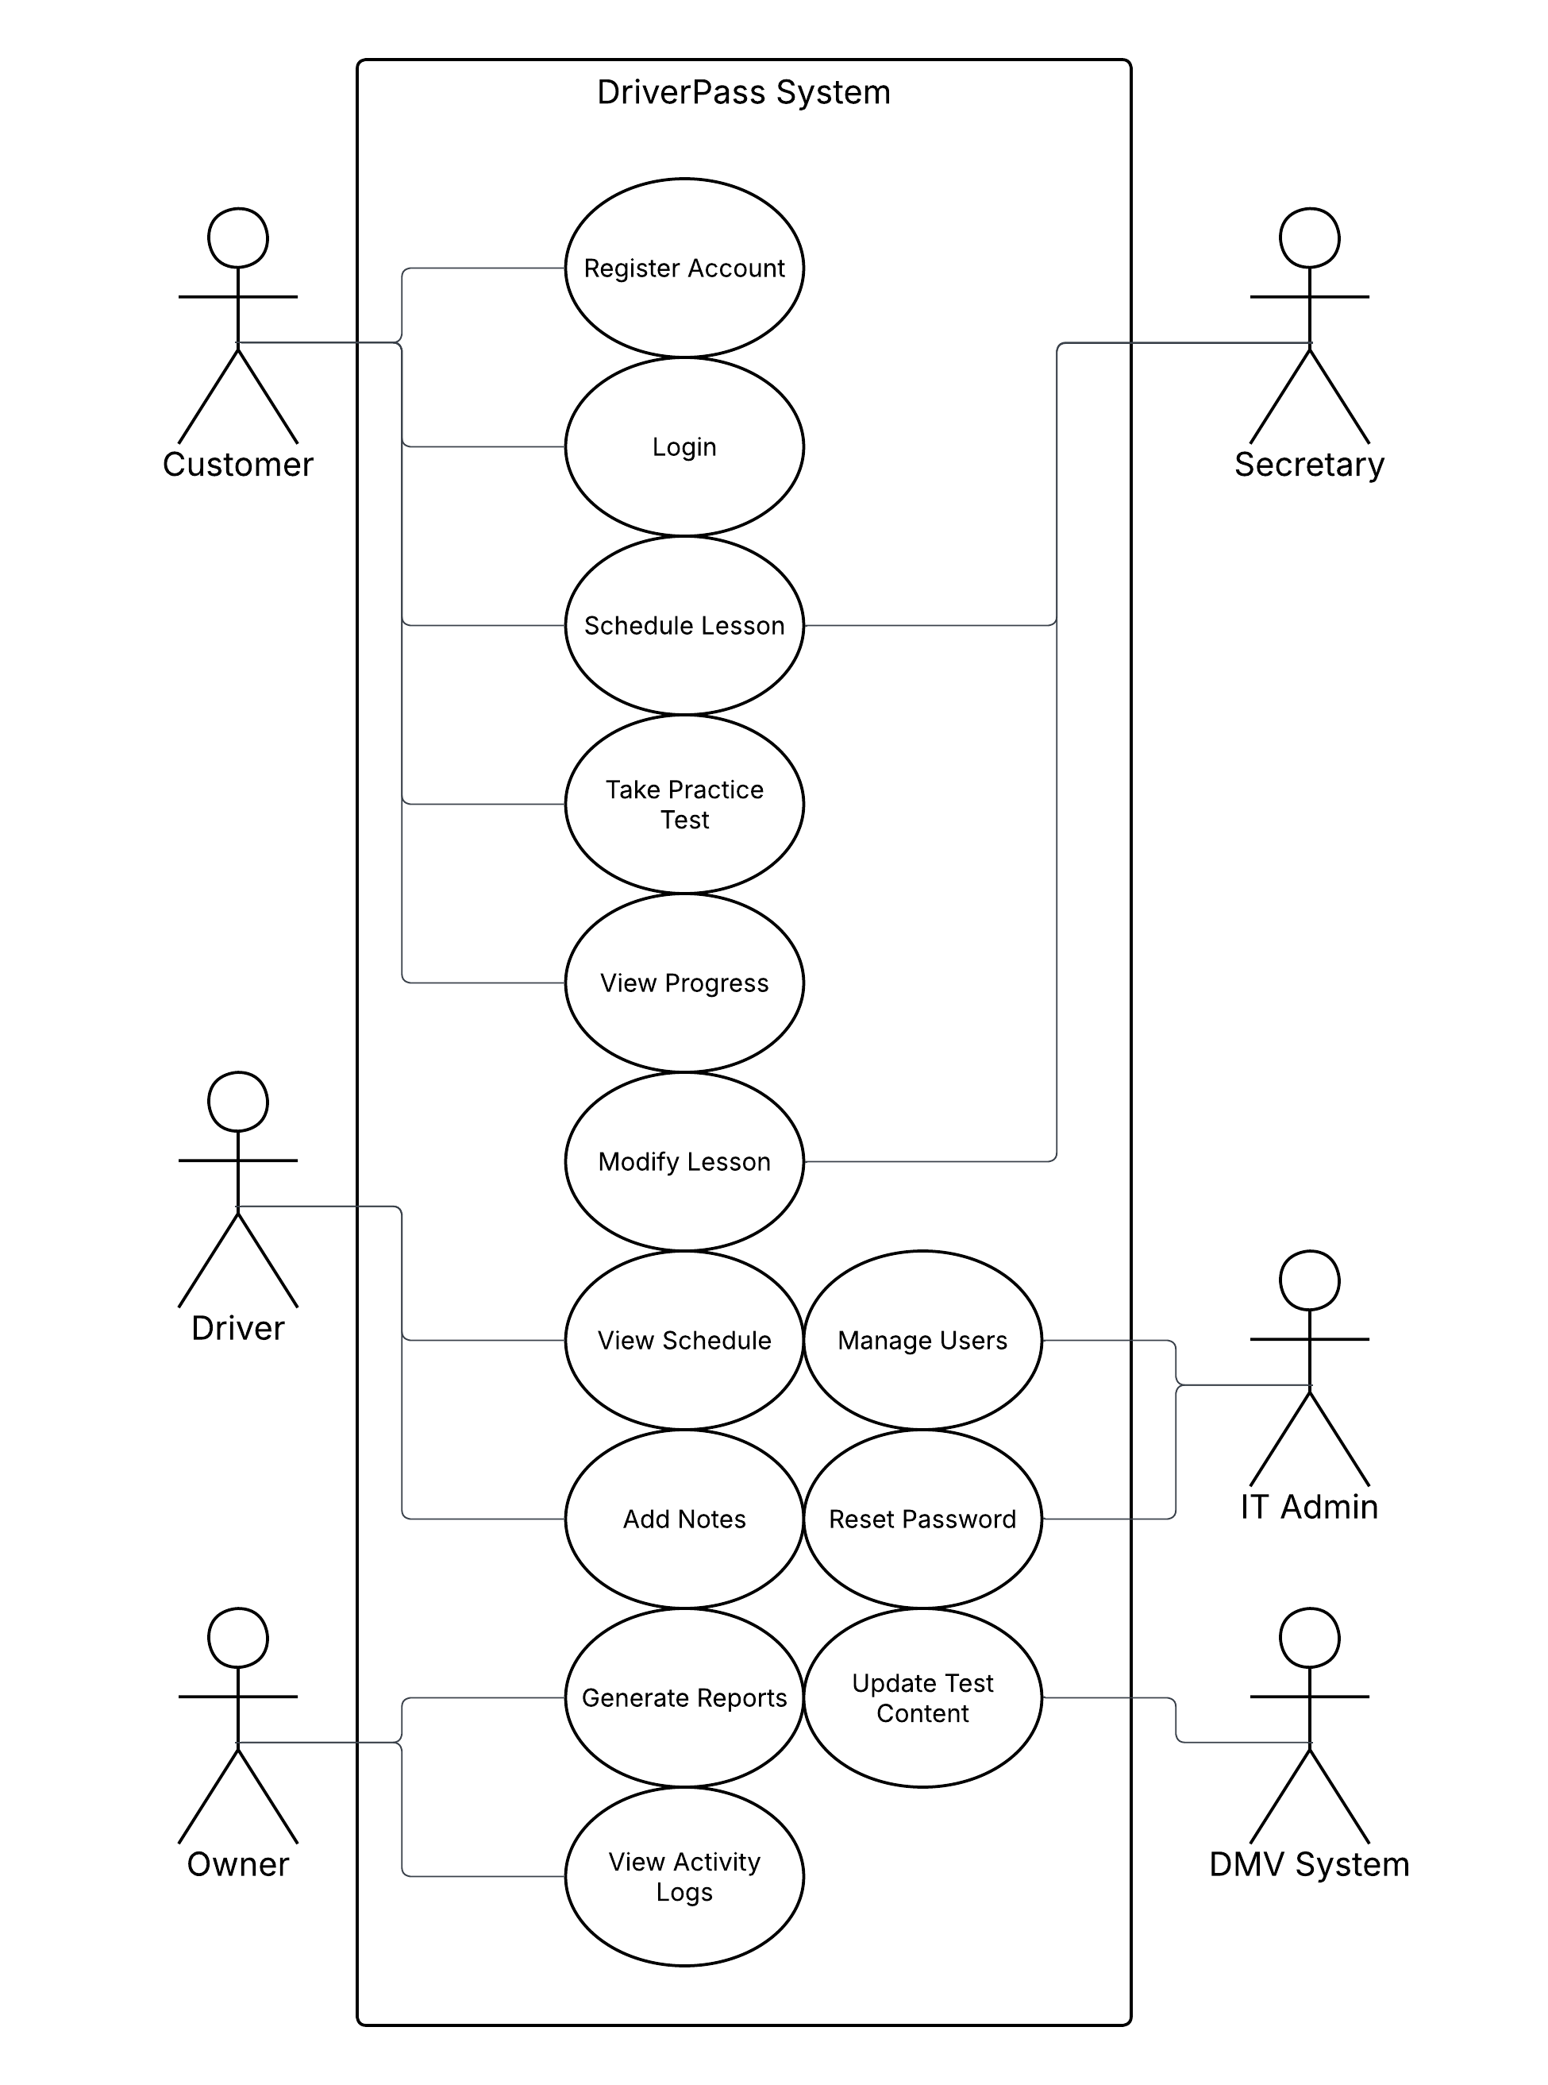

UML Activity Diagrams
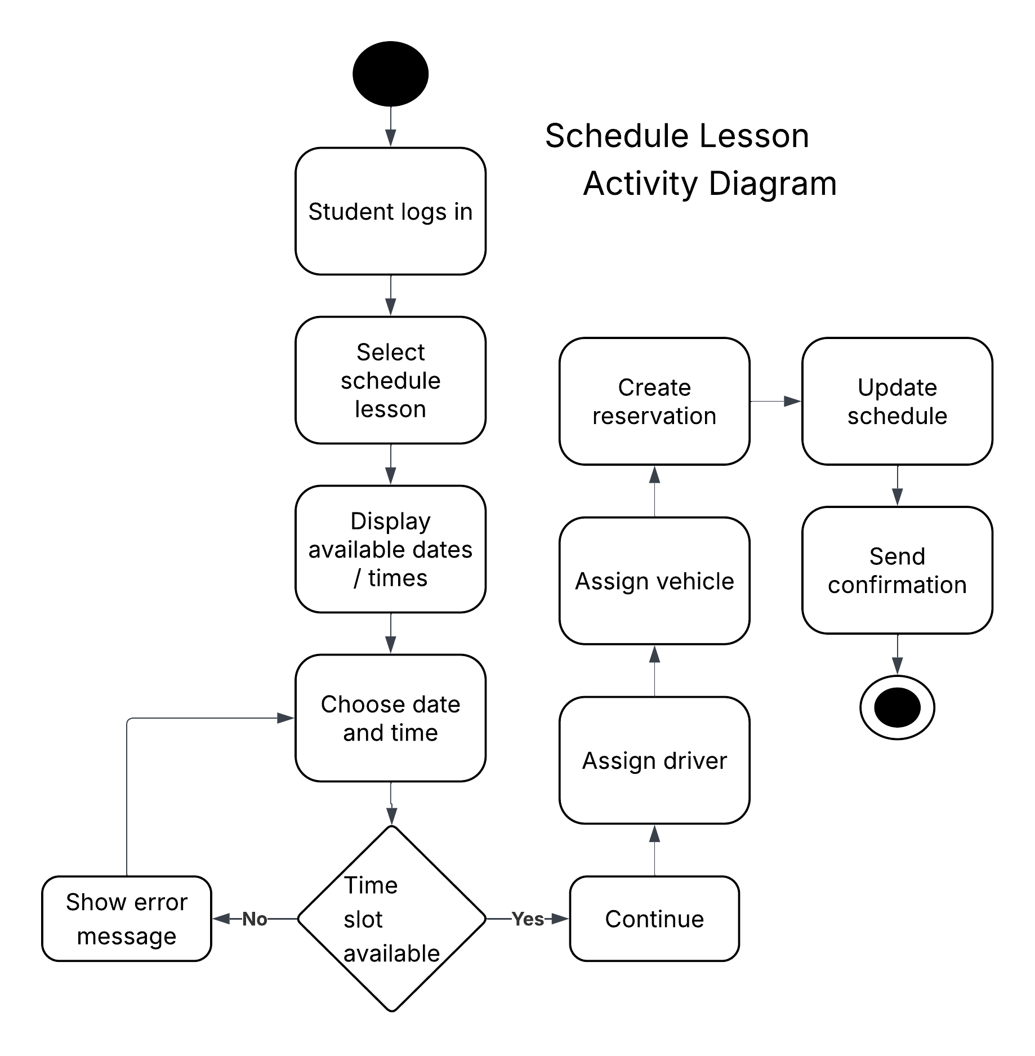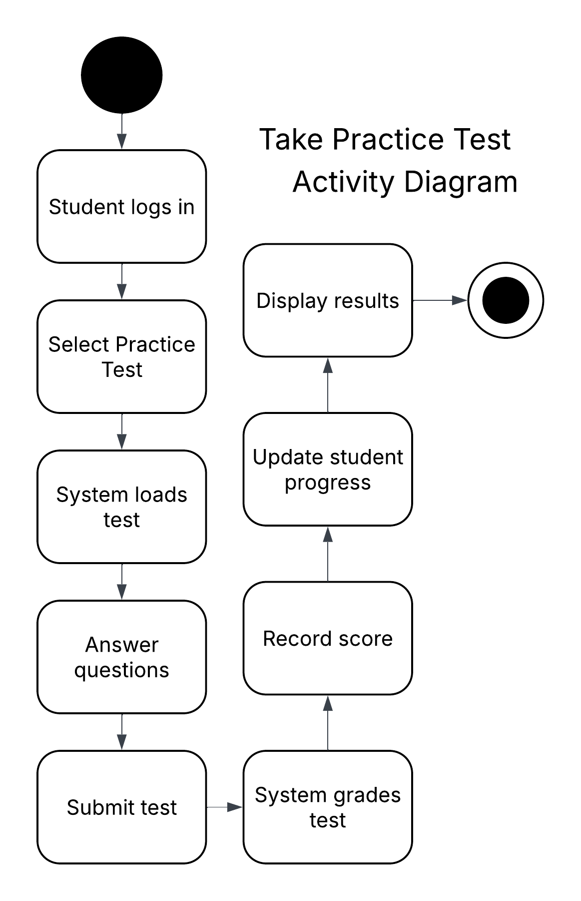

UML Sequence Diagram
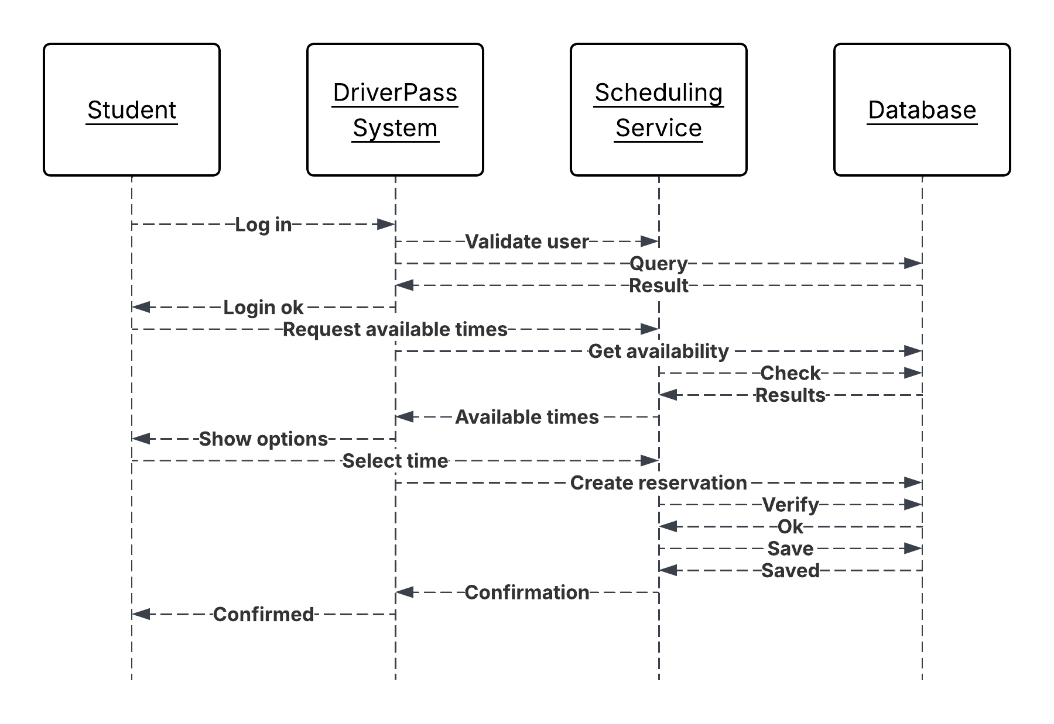

UML Class Diagram
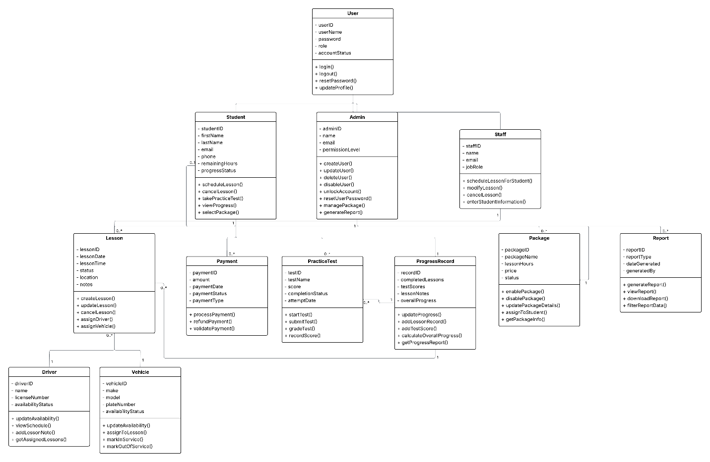

Technical Requirements

Based on the system design and UML diagrams, the DriverPass system will be built as a cloud-based web application. The goal is to have everything in one place for scheduling, training, payments, and reporting, while supporting multiple users at the same time. The system needs to be reliable, secure, and able to grow as more users start using it.

Hardware Requirements
There’s no need for any special hardware on the user side. Students, staff, and admins can all access the system using normal devices like desktops, laptops, tablets, or phones. Since it’s web-based, all they really need is internet access and a browser. On the backend, everything will run on cloud servers that handle storage, processing, and overall performance.

Software Requirements
The system will run in common web browsers like Chrome, Edge, or Safari, so it works across Windows, macOS, and mobile devices. On the backend, server-side software will handle the main functionality like scheduling lessons, managing accounts, processing payments, and tracking progress. There will also be a database system to store important data like users, schedules, instructors, vehicles, and payment info.

Tools and Technologies
The system will use a cloud platform to keep it scalable and always available. Tools like Lucidchart were used to design the UML diagrams (use case, activity, sequence, and class diagrams). The system will also connect to external services like payment processors to handle transactions securely. On top of that, version control tools and development environments will be used to build and maintain the system over time.

Infrastructure Requirements
The system will run on a cloud-based setup to keep performance high and downtime low. This includes a web server to handle user requests, an application server to run the system logic, and a database server to manage all the data. It also needs to support real-time updates, like when lessons are scheduled or changed, so everyone always sees the latest information. This is important for keeping everything synced across users.

Security Requirements
Security is a big deal for this system. Users will log in with a username and password, and role-based access control will make sure people only have access to what they’re supposed to. All data being sent between the user and the server will be encrypted to protect things like login info and payments. There will also be extra protections like account lockouts after too many failed attempts and password reset options to keep accounts secure.

Performance Requirements
The system needs to handle multiple users at once without slowing down. Pages like dashboards, scheduling screens, and reports should load fast so the experience feels smooth. It also needs live updates so when something changes, like a lesson or reservation, it shows up right away for everyone. This helps make sure the system stays responsive and up to date at all times.

